Lab 7 – Cell Division and Cytogenetics (Important Questions to Consider)

Utsav Acharya, BIO 1120 Section 03

Instructor: Christina Minassian

(Important Questions to Consider)

1. Which phases of mitosis did you see the most and least examples of in your microscopic examination of onion root tips?

Answer:

Most common phase: Interphase

Least common phase: Anaphase

2. What conclusions can you draw about the relative length of each mitosis stage from your examination of onion root tips?

Answer:

Interphase lasts longer than other stages; anaphase is shorter and quicker.

3.What onion cells would you have to look at to examine meiosis as well as mitosis?

Answer:

Sex cells (gametes)

4.Is the chromosome you chose to sketch metacentric, submetacentric, or acrocentric?

Answer:

Metacentric

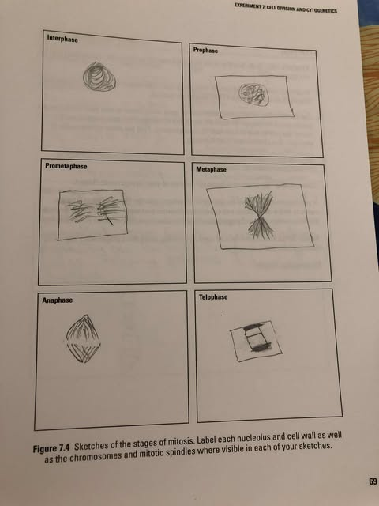

Cytogenetics Report #1

Case Study ID: C

Patient Name: Jocelyn

Age: 41

Sex: F

Reason for Referral: Pregnancy in older age, increased risk of chromosomal abnormality

Chromosomal Findings:

Total number: 46

Type and number of sex chromosomes: XY

Translocation between chromosomes 14 and 21

Patient Diagnosis: Down Syndrome

Implications:

Congenital heart defects

Digestive blockage

Increased risk of leukemia and respiratory issues

Hearing problems and developmental delays

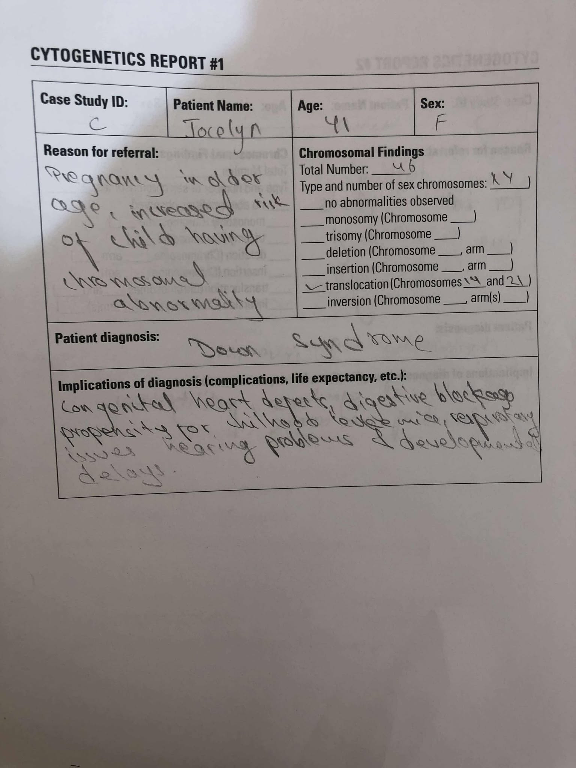

Cytogenetics Report #2

Case Study ID: O

Patient Name: Nadia

Age: 39

Sex: F

Reason for Referral: Genetic testing for birth defects due to pregnancy in older age

Chromosomal Findings:

Total number: 46

Type and number of sex chromosomes: XX

Inversion on chromosome 9

Patient Diagnosis: Chromosome 9 inversion

Implications:

No clinical symptoms

Higher risk of some cancers

Potential fertility issues

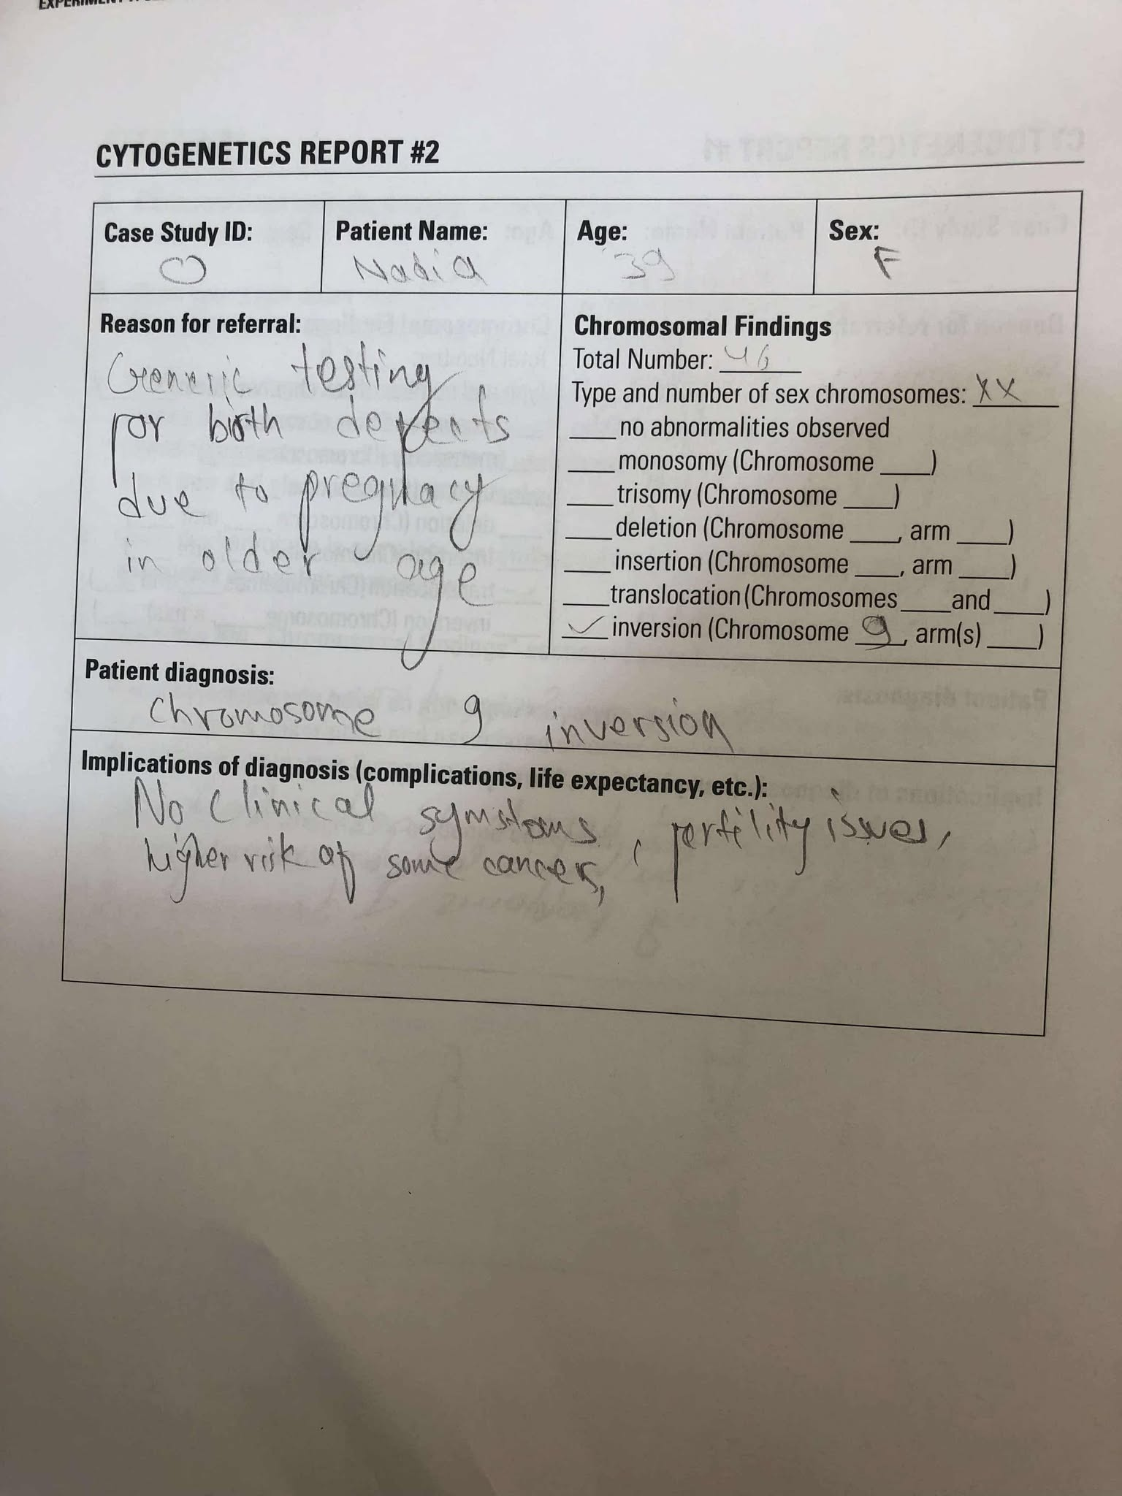

Chromosome Sketch:

